

**Capstone Project Report**

**Report 6 – Software User Guides**

– Hanoi, August 2019 –

**Table of Contents**

I. Project Report 3

1. Status Report 3

2. Team Involvements 3

3. Issues/Suggestions 3

II. Release Package & User Guides 4

1. Deliverable Package 4

1.1 Source codes & documents 4

1.2 Known Issues, Limitations & Restrictions 4

2. Installation Guides 4

2.1 System Requirements 4

2.2 Setup Files 4

2.3 Installation Instruction 4

3. User Manual 4

3.1 Terms and definitions 4

3.2 System requirements 4

3.3 Application Usage 5

3.4 Troubleshooting 5

# I. Release Package & User Guides

## 1. Deliverable Package

### Documents

|  |  |  |
| --- | --- | --- |
| **No.** | **Items** | **Reference** |
| **1** | Mumbi Document | [Mumbi Document](https://drive.google.com/drive/folders/1DjlNHjuP8RjWHeyc4Zfa_1qxY0G-tZZd?usp=sharing) |
| **2** | Unit Test Document | [Unit Test](https://docs.google.com/spreadsheets/d/1Dy9irRM-nW5F9apZIn-xHifClpLSq9XJ/edit?usp=sharing&ouid=112262914123854407093&rtpof=true&sd=true) |
| **3** | System Test Document | [System Test](https://docs.google.com/spreadsheets/d/1bDUy80oQxxUAwC5Ad1zD9MJ7H3I_EEq2/edit?usp=sharing&ouid=112262914123854407093&rtpof=true&sd=true) |

Table 115 - Release Package: Document

### Source codes

|  |  |  |
| --- | --- | --- |
| **No.** | **Items** | **Reference** |
| **1** | Mumbi Server | [Mumbi Server](https://drive.google.com/drive/folders/1NysJrzkxeRdsr2x8PEwziUrYPWrpWQRK?usp=sharing) |
| **2** | Mumbi Staff Web Application | [Mumbi Web](https://drive.google.com/drive/folders/1dFNJmcQTh6CDpaqx0SmA7flcQsey6mKs?usp=sharing) |
| **3** | Mumbi Client Mobile Application | [Mumbi Client](https://drive.google.com/drive/folders/1Ajh7_igGXy687us8_dJgwEDNtiNRr6iC?usp=sharing) |

Table 116 - Release Package: Source Code

## Installation Guides

### Front-End Deployment

Download and install Nodejs

In Front-end source code, config the Firebase project

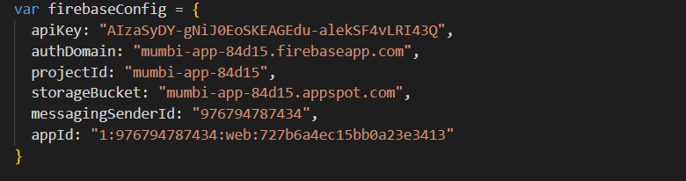

Use the command: *npm run build* to build project.

After that, use command: *npm run deploy* to deploy the application to AWS.

## 3. User Manual

1

### 3.1. Staff create news

|  |  |  |
| --- | --- | --- |
| **No.** | **Name** | **Description** |
| **1** | Thêm tin mới | Create a new news |

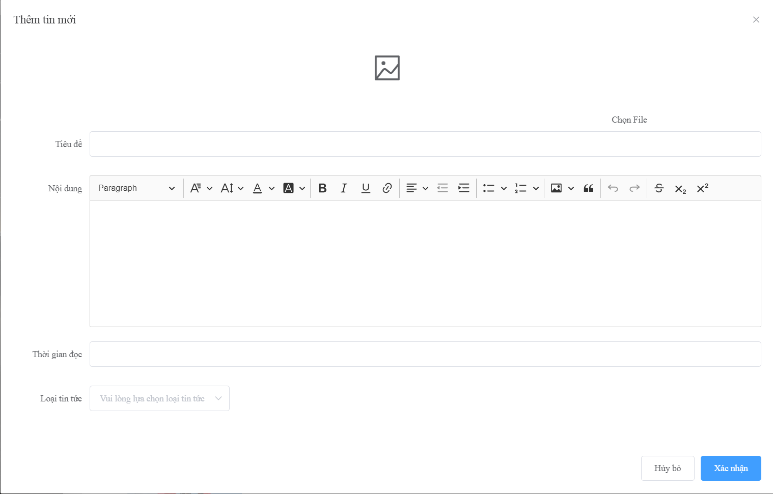

1

2

3

4

5

6

7

|  |  |  |  |  |  |  |
| --- | --- | --- | --- | --- | --- | --- |
| **No** | **Name** | **Description** | **Read Only** | **Mandatory** | **Control Type** | **Data Type** |
| **1** | Chọn File | Select file image to upload | No | Yes | File Upload | File |
| **2** | Tiêu đề | The title of news | No | Yes | Text Box | String |
| **3** | Nội dung | The content of news | No | Yes | Text Box | String |
| **4** | Thời gian đọc | Estimated finish time of news | No | Yes | Text box | Int |
| **5** | Loại tin tức | Type of news | No | Yes | Select | String |

|  |  |  |  |
| --- | --- | --- | --- |
| **No** | **Name** | **Description** | **Validation** |
| **6** | Hủy bỏ | Cancel create news | Yes |
| **7** | Xác nhận | Confirm to create news | Yes |

### 3.2. Staff create news type

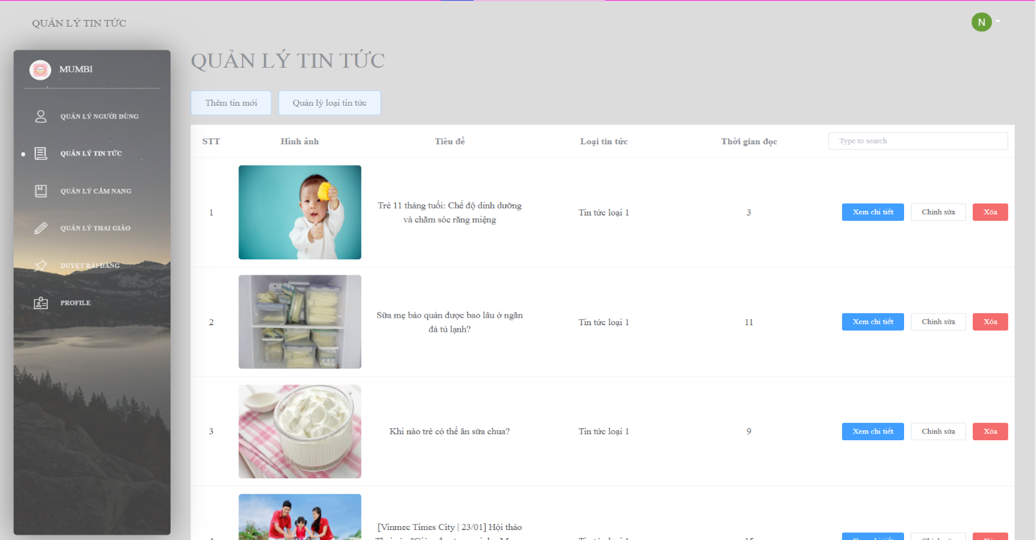

1

1

1

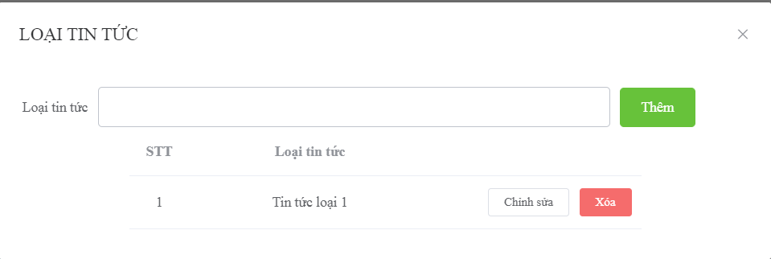

1

1

1

2

1

21

3

1

1

4

1

1

|  |  |  |
| --- | --- | --- |
| **No.** | **Name** | **Description** |
| **1** | Quản lý loại tin tức | Manage type of news |

|  |  |  |  |  |  |  |
| --- | --- | --- | --- | --- | --- | --- |
| **No** | **Name** | **Description** | **Read Only** | **Mandatory** | **Control Type** | **Data Type** |
| **1** | Loại tin tức | Type of news | No | Yes | Text Box | String |

|  |  |  |  |
| --- | --- | --- | --- |
| **No** | **Name** | **Description** | **Validation** |
| **2** | Thêm | Button to create type of news | Yes |
| **3** | Chỉnh sửa | Button to edit type of news | Yes |
| **4** | Xóa | Button to delete type of news | Yes |

### 3.3. Staff create guidebook

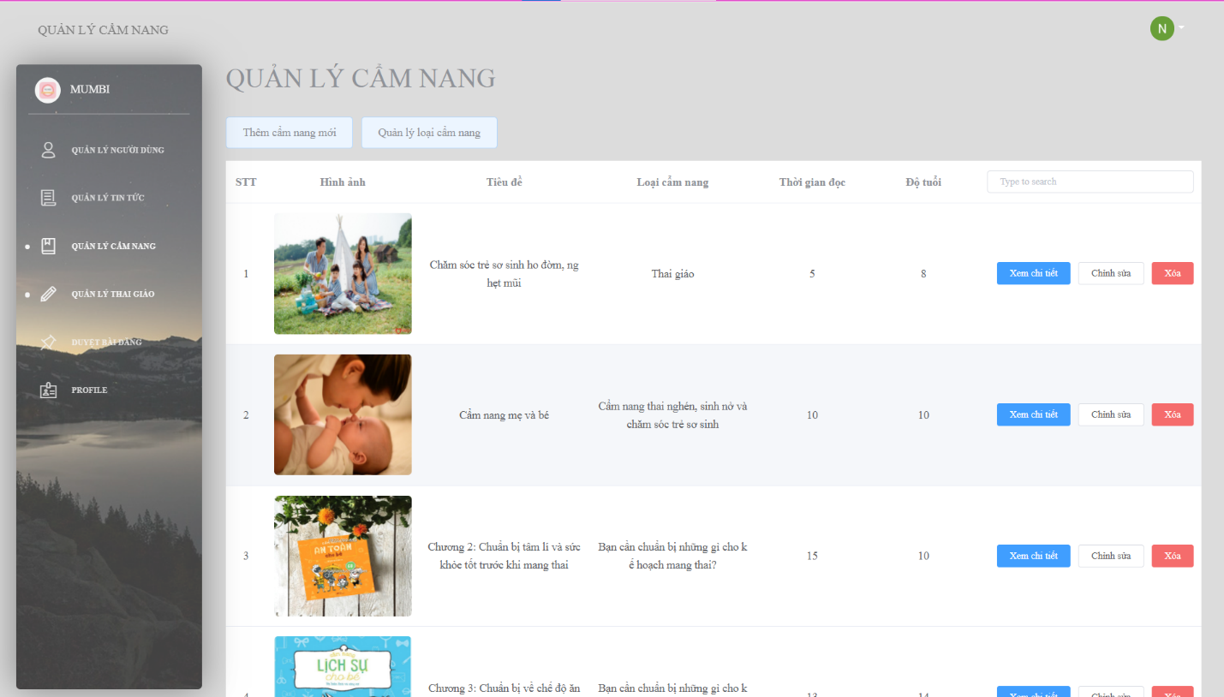

1

1

1

|  |  |  |
| --- | --- | --- |
| **No.** | **Name** | **Description** |
| **1** | Thêm cẩm nang mới | Create a new guidebook |

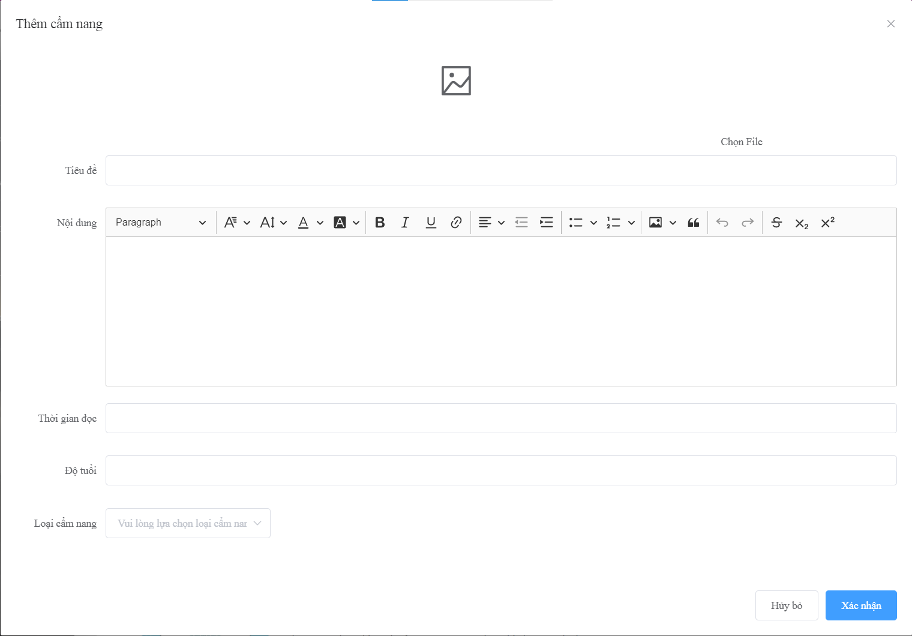

1

2

3

4

5

6

7

8

|  |  |  |  |  |  |  |
| --- | --- | --- | --- | --- | --- | --- |
| **No** | **Name** | **Description** | **Read Only** | **Mandatory** | **Control Type** | **Data Type** |
| **1** | Chọn File | Select file image to upload | No | Yes | File Upload | File |
| **2** | Tiêu đề | The title of guidebook | No | Yes | Text Box | String |
| **3** | Nội dung | The content of guidebook | No | Yes | Text Box | String |
| **4** | Thời gian đọc | Estimated finish time of guidebook | No | Yes | Text box | Int |
| **5** | Độ tuổi | Available age for guidebook | No | Yes | Text box | Int |
| **6** | Loại cẩm nang | Type of guidebook | No | Yes | Select | String |

|  |  |  |  |
| --- | --- | --- | --- |
| **No** | **Name** | **Description** | **Validation** |
| **7** | Hủy bỏ | Cancel create guidebook | Yes |
| **8** | Xác nhận | Confirm to create guidebook | Yes |

### 3.4. Staff create guidebook type

4

1

1

3

1

1

2

1

21

1

11

1

1

1

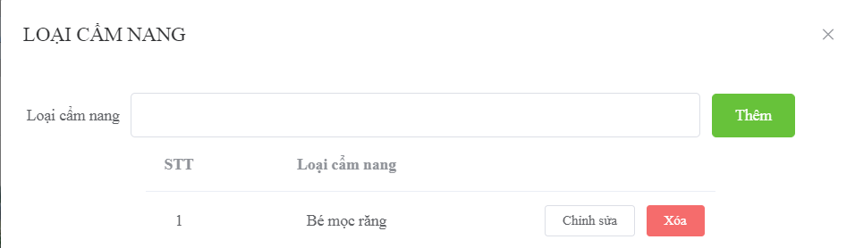

|  |  |  |  |  |  |  |
| --- | --- | --- | --- | --- | --- | --- |
| **No** | **Name** | **Description** | **Read Only** | **Mandatory** | **Control Type** | **Data Type** |
| **1** | Loại cẩm nang | Type of guidebook | No | Yes | Text Box | String |

|  |  |  |  |
| --- | --- | --- | --- |
| **No** | **Name** | **Description** | **Validation** |
| **2** | Thêm | Button to create type of guidebook | Yes |
| **3** | Chỉnh sửa | Button to edit type of guidebook | Yes |
| **4** | Xóa | Button to delete type of guidebook | Yes |

### 3.5. Staff create activity

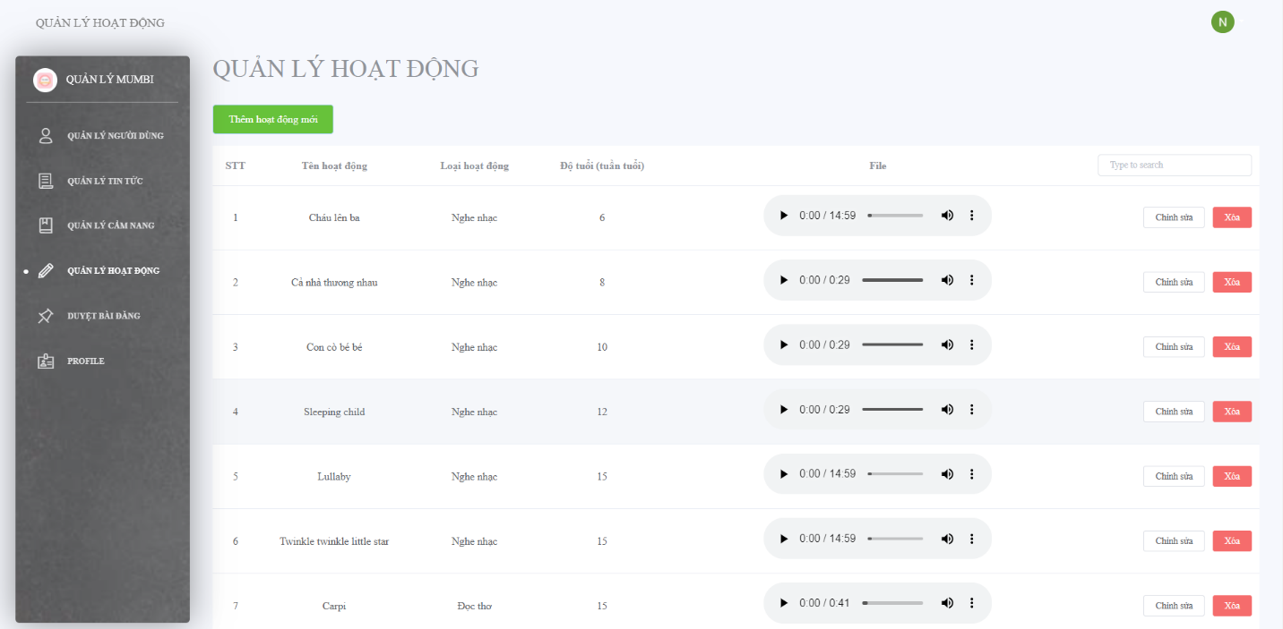

1

1

1

|  |  |  |
| --- | --- | --- |
| **No.** | **Name** | **Description** |
| **1** | Thêm hoạt động mới | Create a new activity |

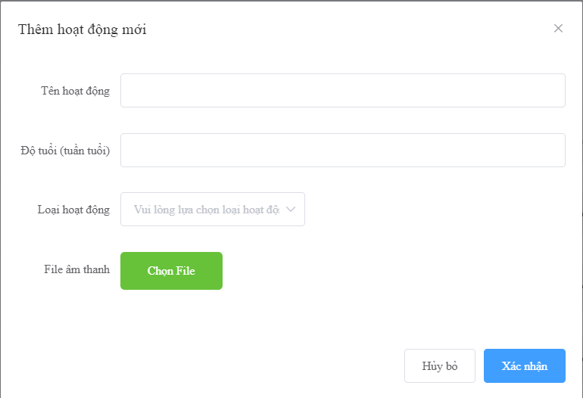

1

1

1

2

1

1

3

1

1

4

1

1

5

1

1

6

1

1

|  |  |  |  |  |  |  |
| --- | --- | --- | --- | --- | --- | --- |
| **No** | **Name** | **Description** | **Read Only** | **Mandatory** | **Control Type** | **Data Type** |
| **1** | Tên hoạt động | The name of activity | No | Yes | Text Box | String |
| **2** | Độ tuổi(tuần tuổi) | The suitable age of activity | No | Yes | Text Box | String |
| **3** | Loại hoạt động | The type activity of activity | No | Yes | Select | String |
| **4** | Chọn File | Select file audio to upload | No | Yes | File Upload | File |

|  |  |  |  |
| --- | --- | --- | --- |
| **No** | **Name** | **Description** | **Validation** |
| **5** | Hủy bỏ | Button to cancel create activity | Yes |
| **6** | Xác nhận | Button to confirm create activity | Yes |

1. **Customer**

### Overview

### a. Login

****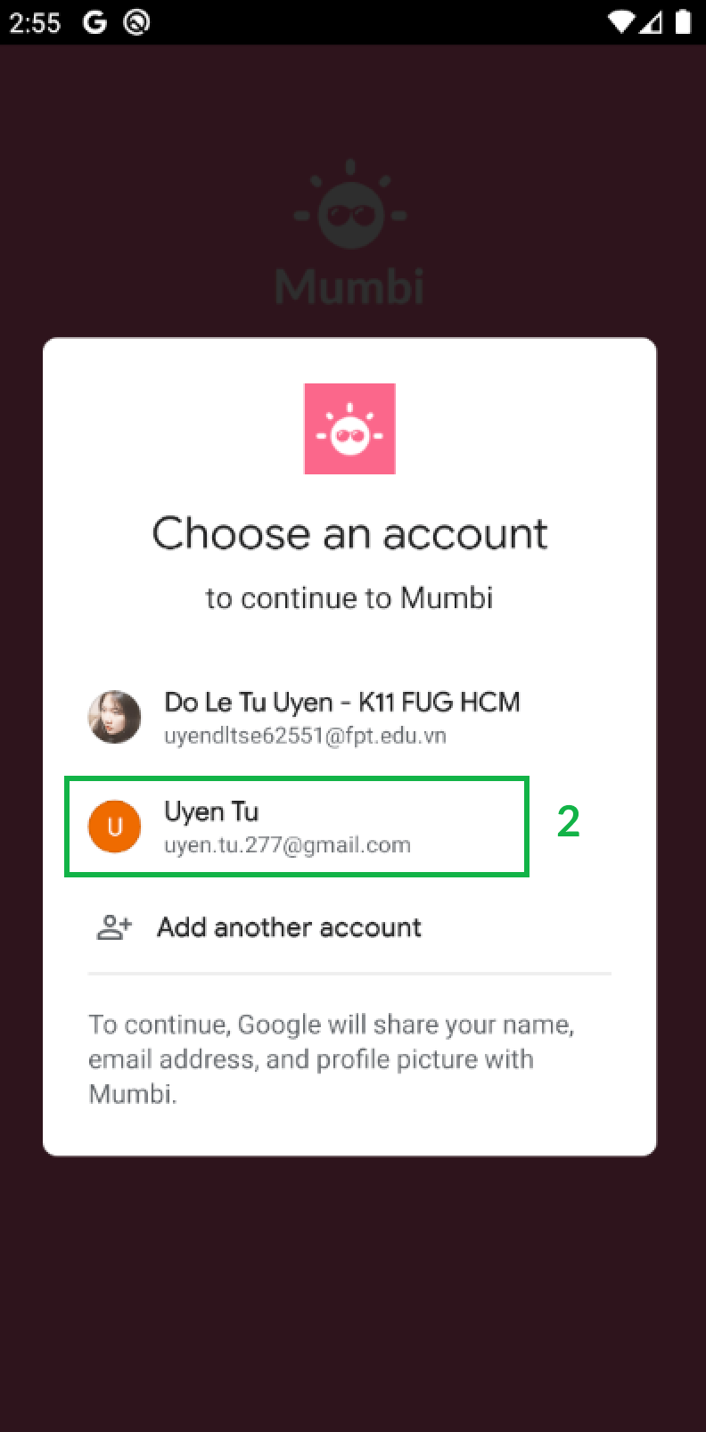

|  |  |  |  |
| --- | --- | --- | --- |
| **No** | **Name** | **Description** | **Validation** |
| **1** | Đăng nhập qua Google | Click button to login by Gmail | Yes |
| **2** | Chọn một tài khoản | Click item to choose account to login in the system | Yes |

### b. Homepage

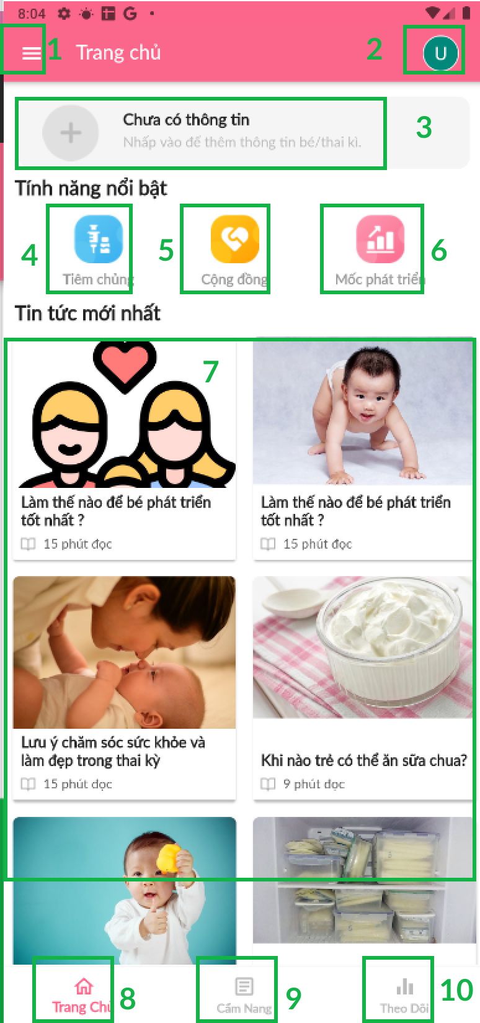

|  |  |  |  |
| --- | --- | --- | --- |
| **No** | **Name** | **Description** | **Validation** |
| **1.** | Menu | Click icon to show Menu | Yes |
|  | Chuyển tài khoản | Click icon to navigate to Changing user account screen | Yes |
|  | Thêm thông tin bé/thai kì | Click item to navigate to Adding information baby/pregnancy screen | Yes |
|  | Tiêm chủng | Click icon to navigate to Injection schedule screen | Yes |
|  | Cộng đồng | Click icon to navigate to Community screen | Yes |
|  | Mốc phát triển | Click icon to navigate to Managing baby’s development screen | Yes |
|  | Tin tức mới nhất | Click item to view news | Yes |
|  | Trang chủ | Click icon to navigate to Menu | Yes |
|  | Cẩm nang | Click icon to navigate to Guidebook screen | Yes |
|  | Theo dõi | Click icon to navigate to Tracking baby screen | Yes |

### c. Menu

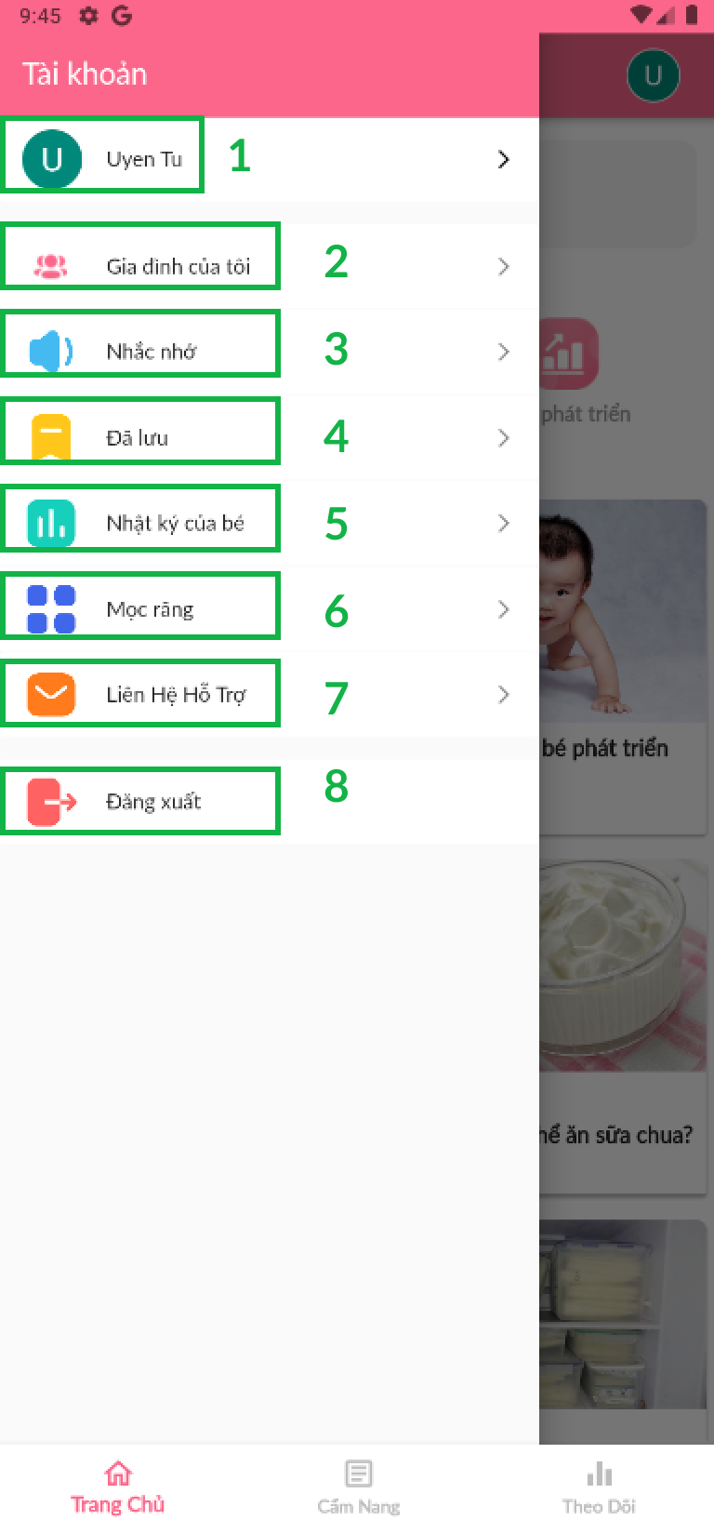

|  |  |  |  |
| --- | --- | --- | --- |
| **No** | **Name** | **Description** | **Validation** |
|  | Chuyển thành viên | Click item to change member | Yes |
|  | Gia đình của tôi | Click item to navigate to Family screen | Yes |
|  | Đã lưu | Click item to navigate to Storing screen | Yes |
|  | Nhật ký của bé | Click item to navigate to Diary’s baby screen | Yes |
|  | Mọc răng | Click item to navigate to Growing teeth screen | Yes |
|  | Liên hệ hỗ trợ | Click item to Contact support screen | Yes |
|  | Đăng xuất | Click item to logout the system | Yes |

### d. Change user account

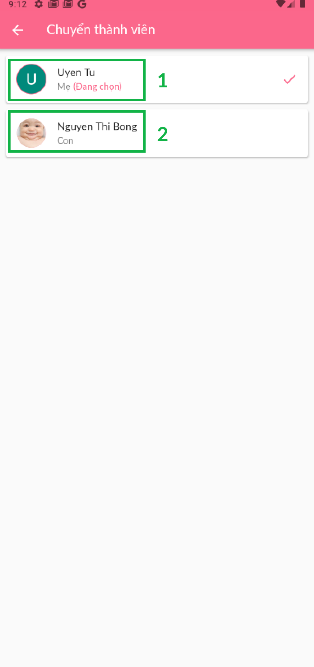

|  |  |  |  |
| --- | --- | --- | --- |
| **No** | **Name** | **Description** | **Validation** |
|  | Tài khoản mẹ | Click item to choose mother’s account | Yes |
|  | Tài khoản con | Click item to choose baby’s account | Yes |

### Create User account data

### Select to create user account data

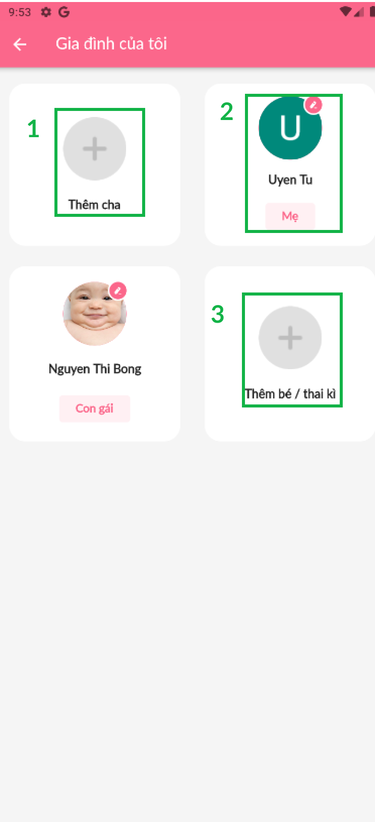

|  |  |  |  |
| --- | --- | --- | --- |
| **No** | **Name** | **Description** | **Validation** |
|  | Thêm cha | Click icon to create father data | Yes |
|  | Mẹ | Click icon to edit mother data | Yes |
|  | Thêm bé/thai kì | Click icon to create baby/pregnancy data | Yes |

### Create father data

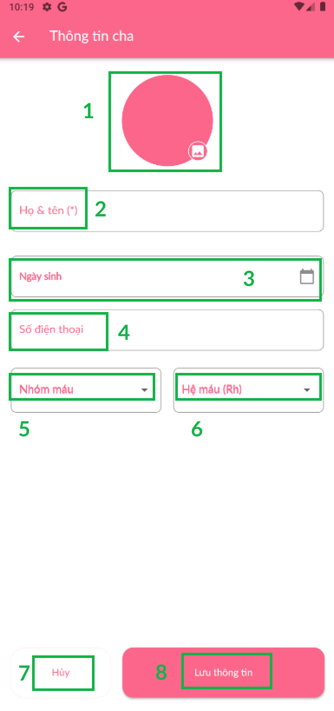

*Figure 88 Create father data*

|  |  |  |  |  |  |  |
| --- | --- | --- | --- | --- | --- | --- |
| **No** | **Name** | **Description** | **Read Only** | **Mandatory** | **Control Type** | **Data Type** |
|  | Ảnh đại diện | Click icon to update father’s avatar | No | Yes | File Upload | File |
|  | Họ và tên | Fill the father’s name | No | Yes | TextBox | Text |
|  | Ngày sinh | Choose father’s date birth | No | Yes | TextBox | DateTime |
|  | Số điện thoại | Fill the father’s phone number | No | Yes | TextBox | Number |
|  | Nhóm máu | Choose father’s blood group | No | Yes | Drop down | String |
|  | Hệ máu (Rh) | Choose father’s Rh blood group | No | Yes | Drop down | String |

|  |  |  |  |
| --- | --- | --- | --- |
| **No** | **Name** | **Description** | **Validation** |
| **7** | Hủy | Click button to cancel | Yes |
| **8** | Lưu thông tin | Click button to save information | Yes |

### Edit mother data

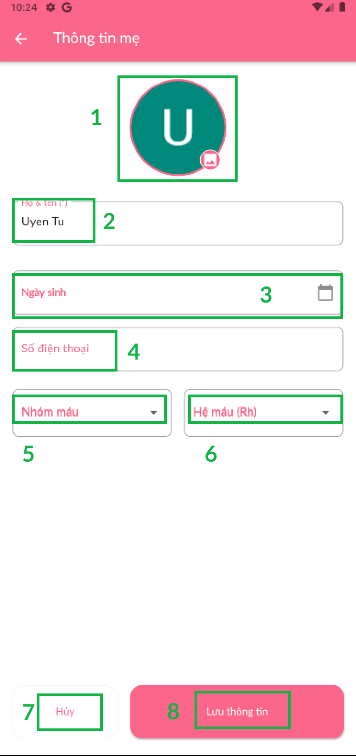

|  |  |  |  |  |  |  |
| --- | --- | --- | --- | --- | --- | --- |
| **No** | **Name** | **Description** | **Read Only** | **Mandatory** | **Control Type** | **Data Type** |
|  | Ảnh đại diện | Click icon to update mother’s avatar | No | Yes | File Upload | File |
|  | Họ và tên | Fill the mother’s name | No | Yes | TextBox | Text |
|  | Ngày sinh | Choose mother’s date birth | No | Yes | TextBox | DateTime |
|  | Số điện thoại | Fill the mother’s phone number | No | Yes | TextBox | Number |
|  | Nhóm máu | Choose father’s blood group | No | Yes | Drop down | String |
|  | Hệ máu (Rh) | Choose father’s Rh blood group | No | Yes | Drop down | String |

|  |  |  |  |
| --- | --- | --- | --- |
| **No** | **Name** | **Description** | **Validation** |
| **7** | Hủy | Click button to cancel | Yes |
| **8** | Lưu thông tin | Click button to save information | Yes |

### Create baby/pregnancy data

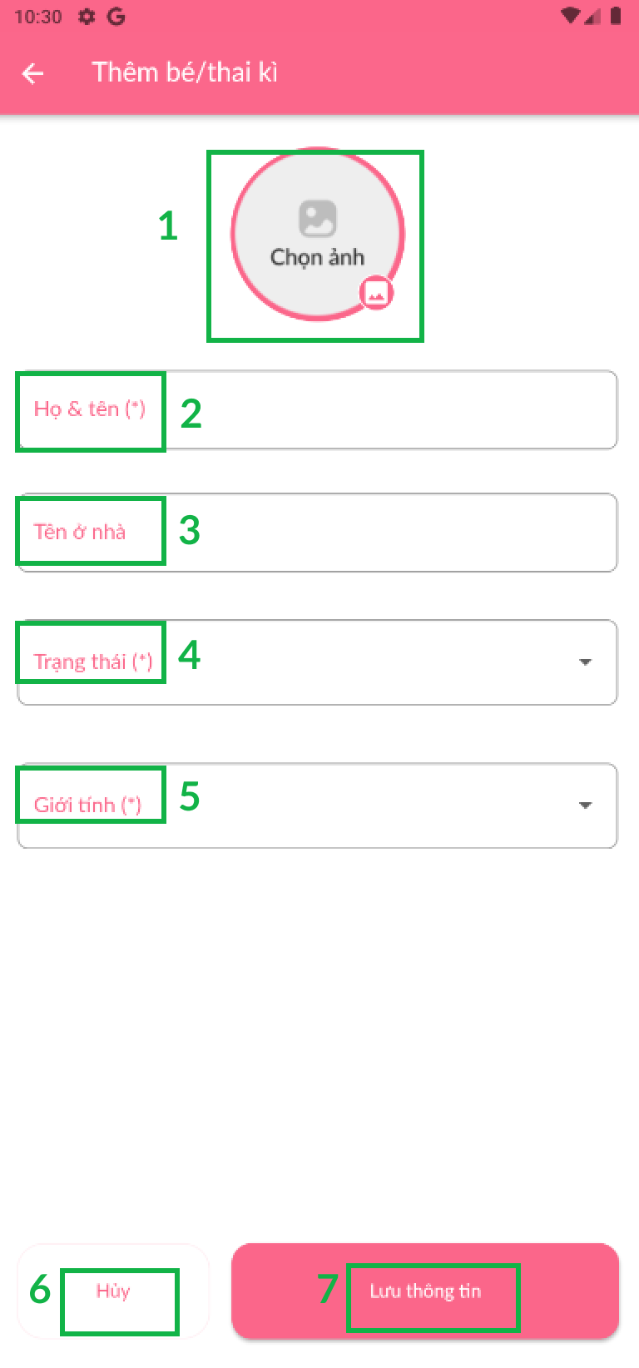

|  |  |  |  |  |  |  |
| --- | --- | --- | --- | --- | --- | --- |
| **No** | **Name** | **Description** | **Read Only** | **Mandatory** | **Control Type** | **Data Type** |
|  | Ảnh đại diện | Click icon to update baby’s avatar | No | Yes | File Upload | File |
|  | Họ và tên | Fill the baby’s name | No | Yes | TextBox | Text |
|  | Tên ở nhà | Fill the baby’s nickname | No | Yes | TextBox | Text |
|  | Trạng thái | Choose the baby’s status | No | Yes | Drop down | String |
|  | Giới tính | Choose the baby’s gender | No | Yes | Drop down | String |

|  |  |  |  |
| --- | --- | --- | --- |
| **No** | **Name** | **Description** | **Validation** |
| **6** | Hủy | Click button to cancel | Yes |
| **7** | Lưu thông tin | Click button to save information | Yes |

### Injection schedule



|  |  |  |  |
| --- | --- | --- | --- |
| **No** | **Name** | **Description** | **Validation** |
| **1** | Thêm | Button to create type of guidebook | Yes |
| **2** | Chỉnh sửa | Button to edit type of guidebook | Yes |

### Community



|  |  |  |  |
| --- | --- | --- | --- |
| **No** | **Name** | **Description** | **Validation** |
| **1** | Nhật kí của bé | Detail baby’s diary | Yes |

### Manage baby’s development

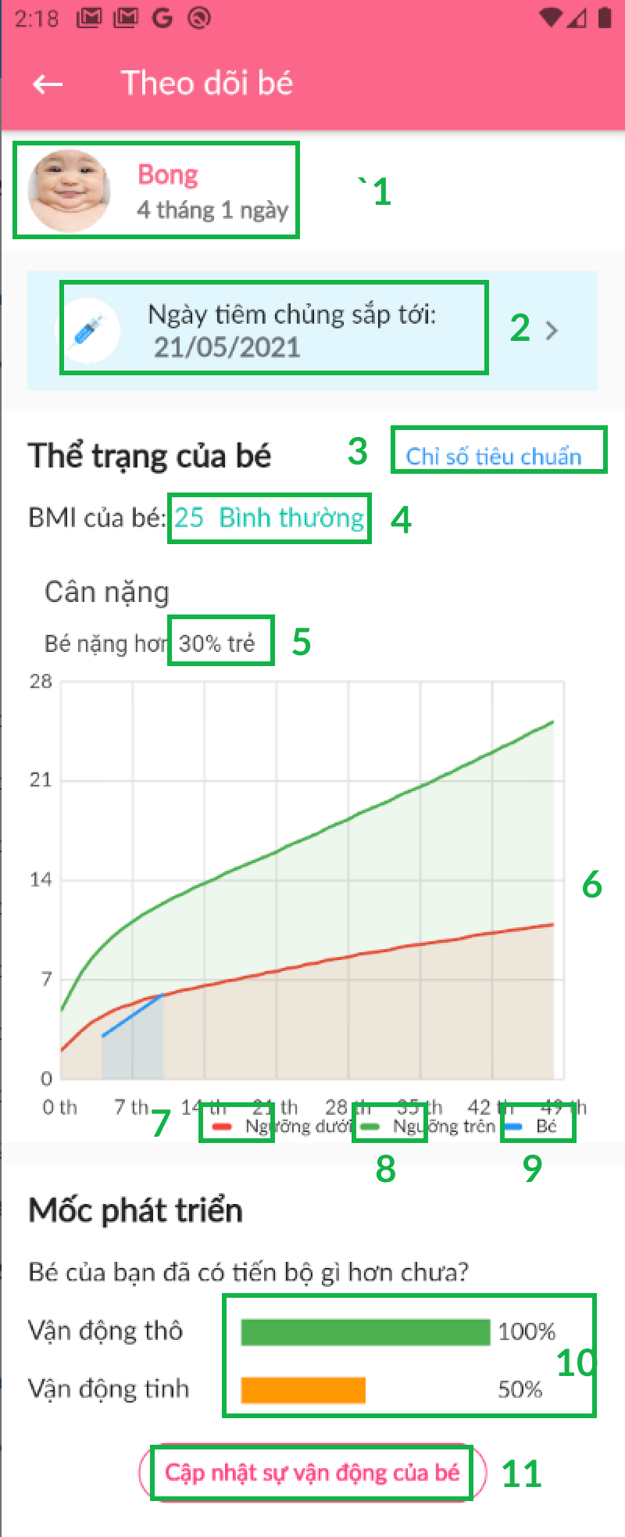

|  |  |  |  |
| --- | --- | --- | --- |
| **No** | **Name** | **Description** | **Validation** |
|  | Thông tin của bé | Detail baby’s information | Yes |
|  | Ngày tiêm chủng sắp tới | The next injection day of baby | Yes |
|  | Chỉ số tiêu chuẩn của bé | Click text to show baby’s standard index data | Yes |
|  | Thể trạng của bé | Baby’s physical condition | Yes |
|  | Cân nặng của bé | Baby’s weight | Yes |
|  | Biểu đồ | Detail maximum-minimum standard index data each month respectively | Yes |
|  | Dữ liệu ngưỡng dưới | Maximum data each month | Yes |
|  | Dữ liệu ngưỡng trên | Minimum data each month | Yes |
|  | Dữ liệu bé | Baby’s data each month | Yes |
|  | Mô tả số vận động tinh-thô của bé | Describe fine-gross motor skills | Yes |
|  | Cập nhật sự vận động của bé | Click button to update baby’s movement | Yes |

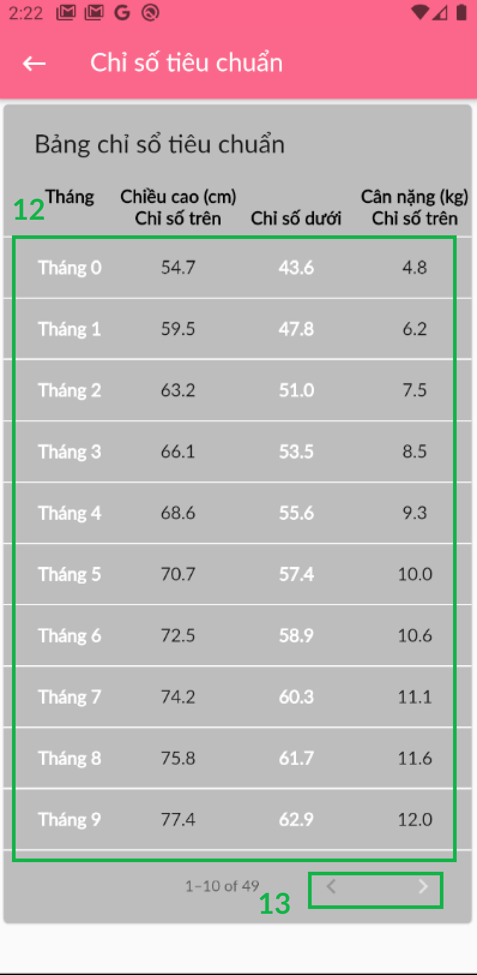

|  |  |  |  |
| --- | --- | --- | --- |
| **No** | **Name** | **Description** | **Validation** |
|  | Chỉ số tiêu chuẩn | Standard index data of baby | Yes |
|  | Icon | Click icon to move next and forward | Yes |

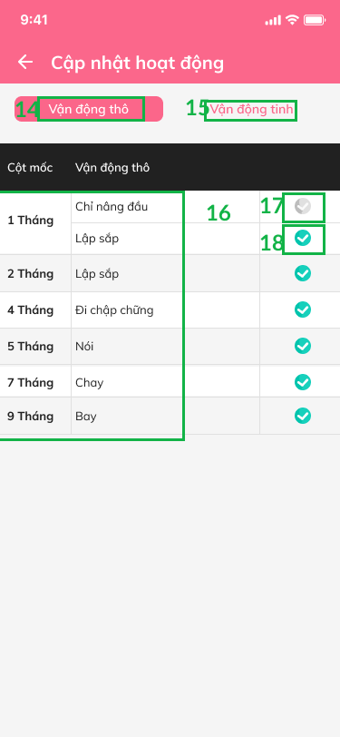

|  |  |  |  |
| --- | --- | --- | --- |
| **No** | **Name** | **Description** | **Validation** |
|  | Vận động thô | Gross motor skill | Yes |
|  | Vận động tinh | Fine motor skill | Yes |
|  | Cột mốc vận động thô | Detail gross motor skill each month | Yes |
|  | Icon | Icon unticked | Yes |
|  | Icon | Icon ticked | Yes |

### View News

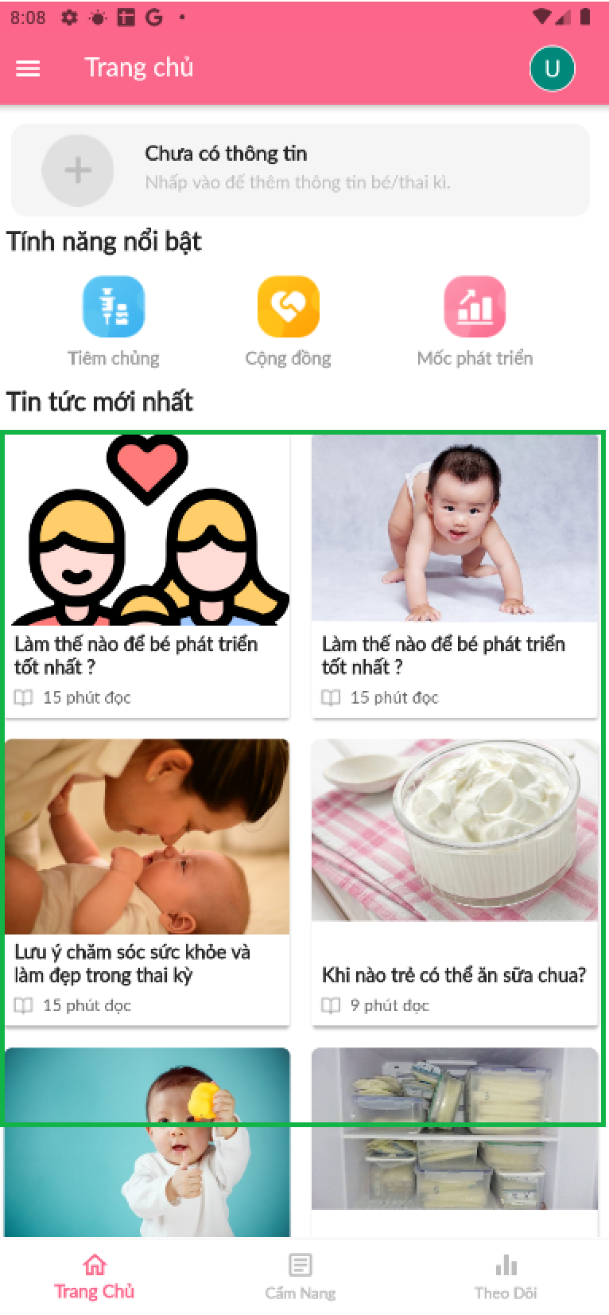

|  |  |  |  |
| --- | --- | --- | --- |
| **No** | **Name** | **Description** | **Validation** |
| **1** | Tin tức mới nhất | Click item to detail news | Yes |

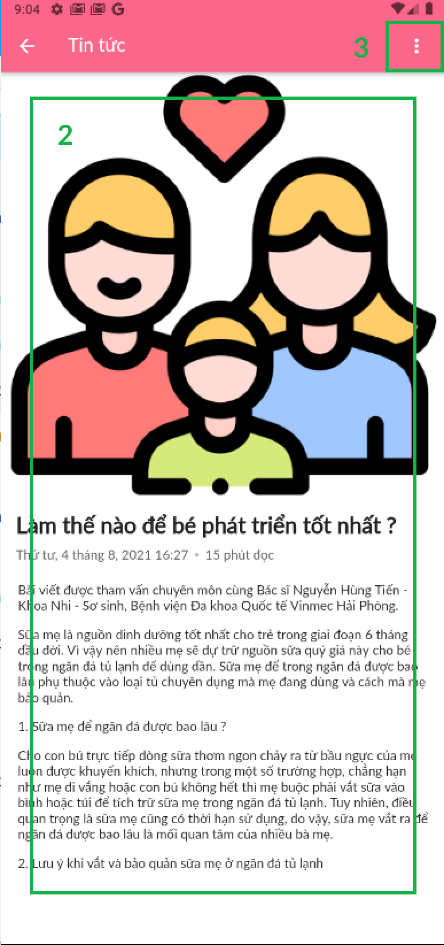

|  |  |  |  |
| --- | --- | --- | --- |
| **No** | **Name** | **Description** | **Validation** |
| **2** | Detail | Detail the description of News | Yes |
| **3** | Icon | Click icon to show saving post system | Yes |

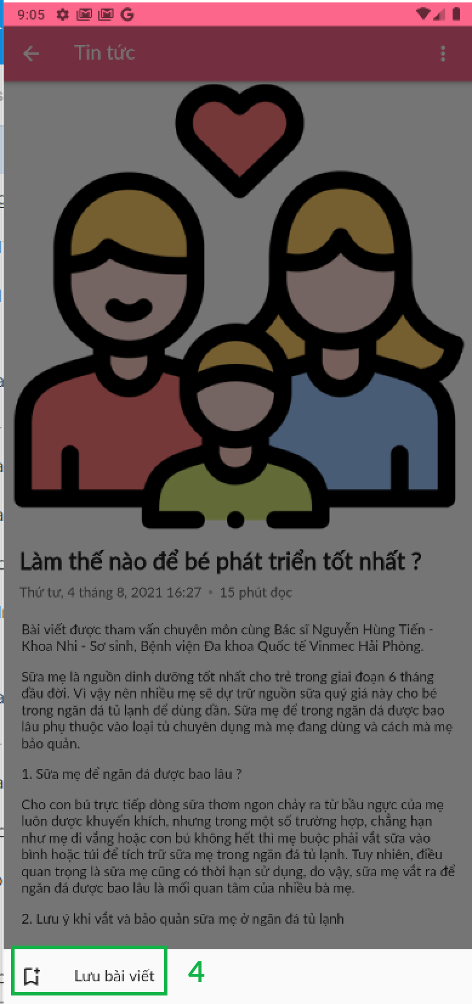

|  |  |  |  |
| --- | --- | --- | --- |
| **No** | **Name** | **Description** | **Validation** |
| **4** | Lưu bài viết | Click item to save post | Yes |

### View guidebook

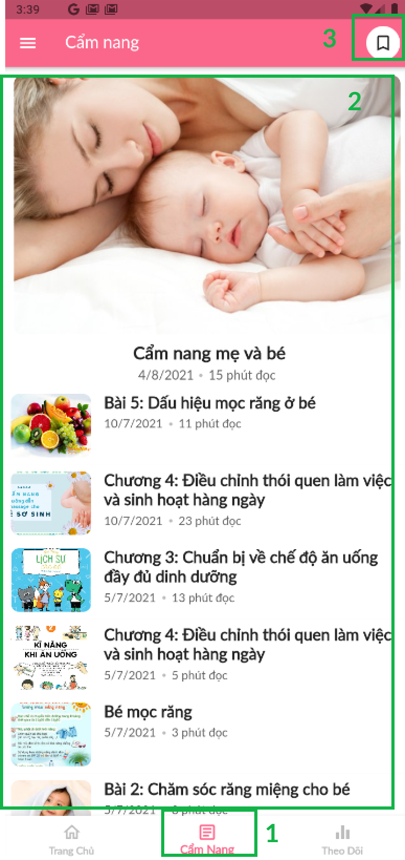

|  |  |  |  |
| --- | --- | --- | --- |
| **No** | **Name** | **Description** | **Validation** |
|  | Cẩm nang | Click icon to show guidebook screen | Yes |
|  | Item | Click to view detail guidebook item | Yes |
|  | Icon | Click icon to | Yes |

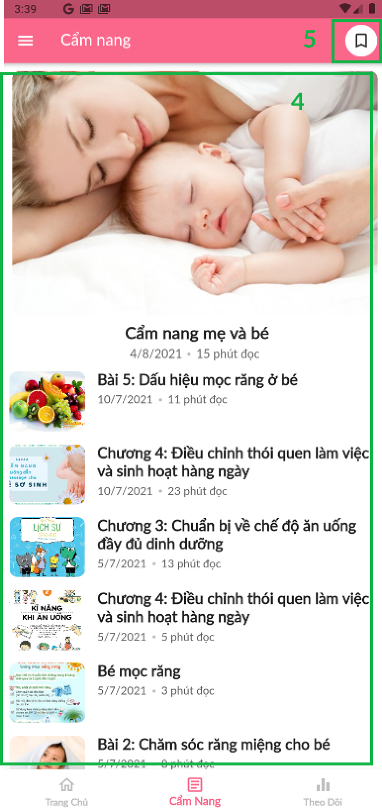

|  |  |  |  |
| --- | --- | --- | --- |
| **No** | **Name** | **Description** | **Validation** |
|  | Bài viết | Detail guidebook | Yes |
|  | Icon | Click icon to show saving post system | Yes |

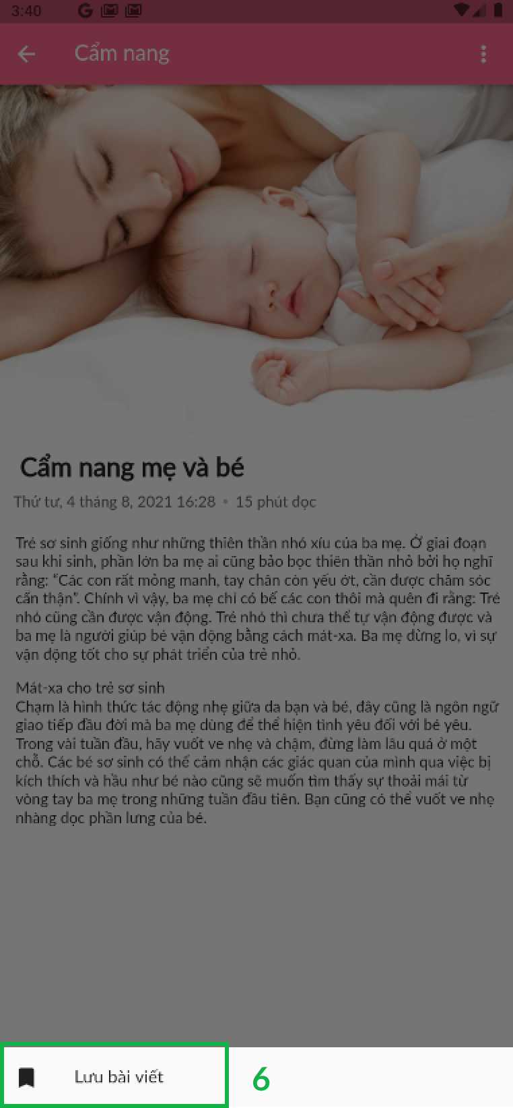

|  |  |  |  |
| --- | --- | --- | --- |
| **No** | **Name** | **Description** | **Validation** |
|  | Lưu bài viết | Click item to save post | Yes |

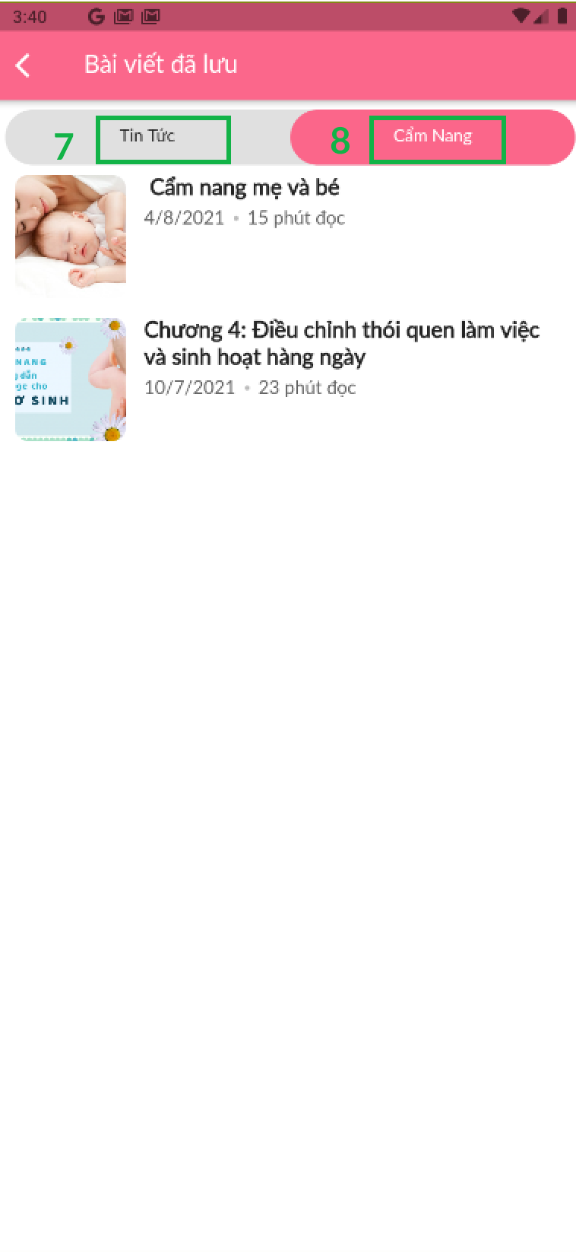

|  |  |  |  |
| --- | --- | --- | --- |
| **No** | **Name** | **Description** | **Validation** |
|  | Tin tức | Click button to show saving news | Yes |
|  | Cẩm nang | Click button to show saving guidebook | Yes |

### Add diary

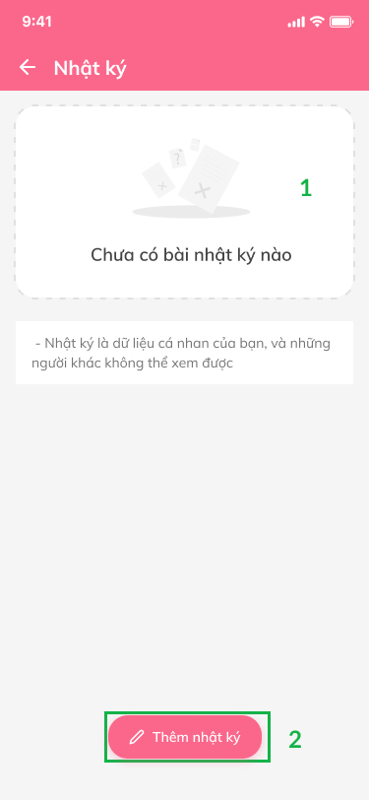 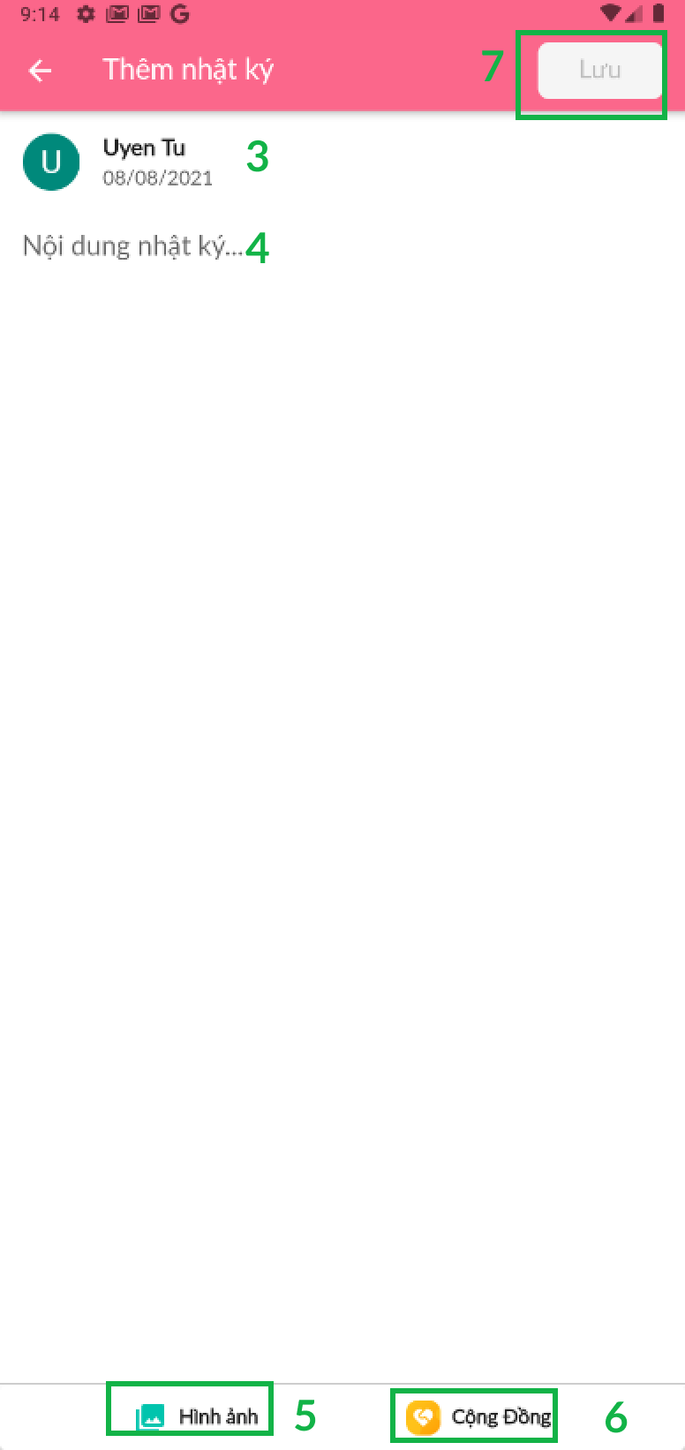

|  |  |  |  |  |  |  |
| --- | --- | --- | --- | --- | --- | --- |
| **No** | **Name** | **Description** | **Read Only** | **Mandatory** | **Control Type** | **Data Type** |
| **4** | Nội dung nhật ký | Click to write down diary | No | Yes | Text Box | String |

|  |  |  |  |
| --- | --- | --- | --- |
| **No** | **Name** | **Description** | **Validation** |
|  | Dữ liệu nhật ký | Diary information | Yes |
|  | Thêm nhật ký | Click item to add diary | Yes |
|  | Item | Detail user account, date time to post diary | Yes |
|  | Hình ảnh nhật ký | Click icon to upload diary image | Yes |
|  | Cộng đồng | Click icon to view Community screen | Yes |
|  | Lưu | Click button to save diary | Yes |

### Check teeth growing process

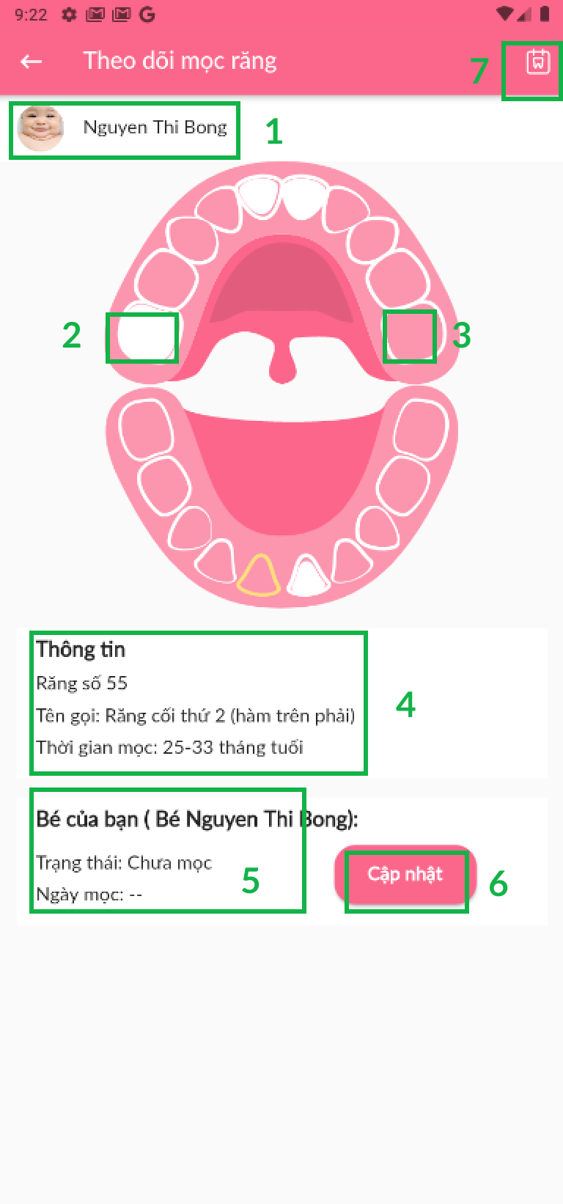 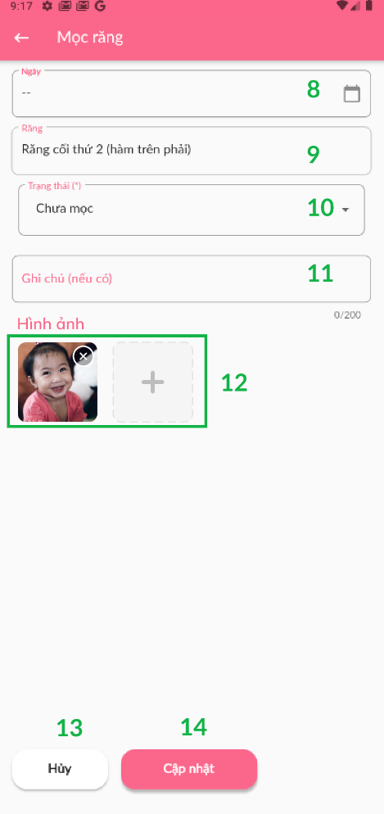 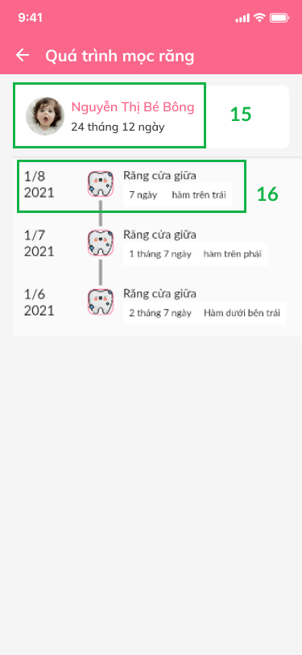

*Figure 89- Check teeth growing process*

|  |  |  |  |  |  |  |
| --- | --- | --- | --- | --- | --- | --- |
| **No** | **Name** | **Description** | **Read Only** | **Mandatory** | **Control Type** | **Data Type** |
|  | Ngày mọc răng | Choose the date growing teeth | No | Yes | TextBox | DateTime |
|  | Tên răng | Name of teeth | No | Yes | TextBox | String |
|  | Trạng thái răng | Choose teeth status | No | Yes | Dropdown | String |
|  | Ghi chú (nếu có) | Fill note (in case) | No | Yes | TextBox | Text |
|  | Upload hình ảnh | Click icon to add the growing teeth image of baby | No | Yes | Image | File |

|  |  |  |  |
| --- | --- | --- | --- |
| **No** | **Name** | **Description** | **Validation** |
|  | Dữ liệu bé | Baby’s name | Yes |
|  | Răng đã mọc | Growed teeth | Yes |
|  | Răng chưa mọc | Ingrown teeth | Yes |
|  | Thông tin răng | Detail teeth: number, name, growing time | Yes |
|  | Thông tin răng của bé | Detail baby’s teeth: status and growing time | Yes |
|  | Cập nhật | Click button to update teeth status | Yes |
|  | Icon | Click icon to show Growing teeth screen | Yes |
|  | Button | Click button to cancel check growing teeth process | Yes |
|  | Button | Click button to update check growing teeth process | Yes |
|  | Item | Detail growing teeth process: baby’s name and growing teeth time | Yes |
|  | Item | Detail growing each teeth process | Yes |

### Manage baby’s action

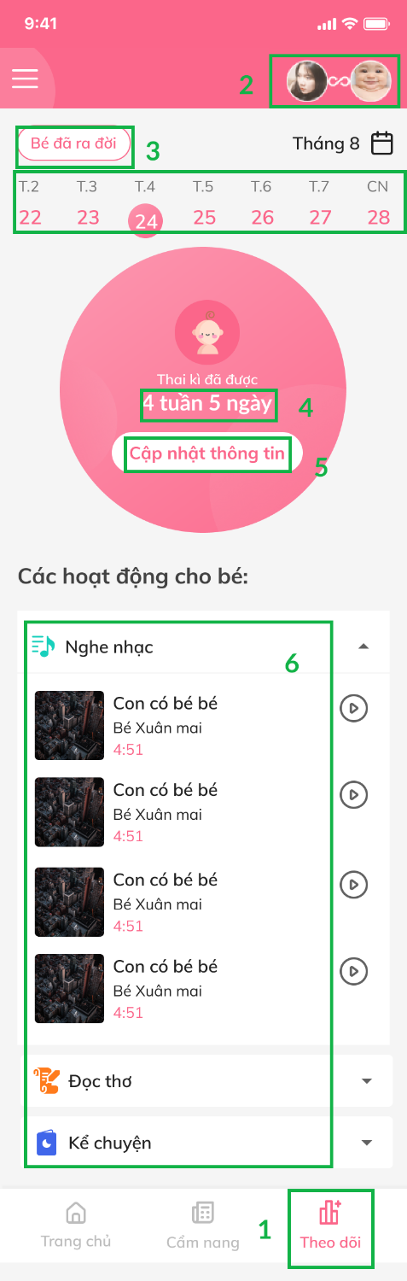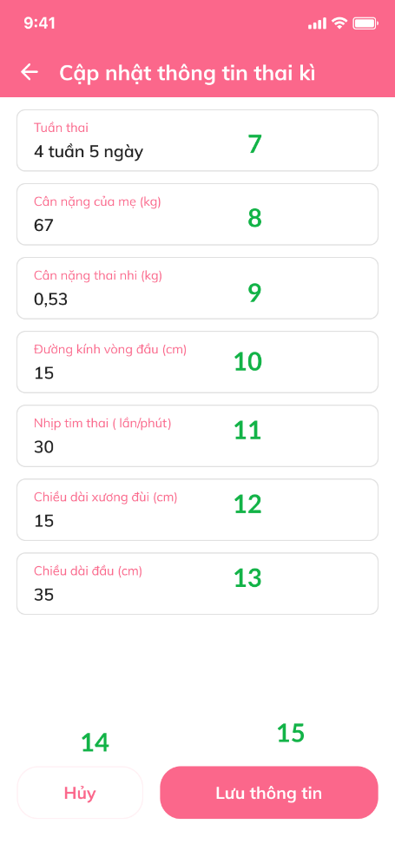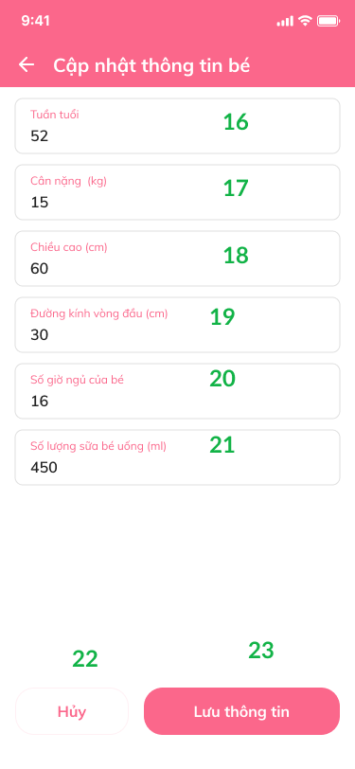

|  |  |  |  |  |  |  |
| --- | --- | --- | --- | --- | --- | --- |
| **No** | **Name** | **Description** | **Read Only** | **Mandatory** | **Control Type** | **Data Type** |
|  | Tuần thai kì | Fill in pregnancy week | No | Yes | TextBox | Text |
|  | Cân nặng của mẹ (kg) | Fill in mom’s weight | No | Yes | TextBox | Text |
|  | Cân nặng thai nhi (kg) | Fill in pregnancy’s weight | No | Yes | TextBox | Text |
|  | Đường kính vòng đầu (cm) | Fill in first round diameter (cm) | No | Yes | TextBox | Text |
|  | Nhịp tim thai (lần/phút) | Fill in the heart beat of pregnancy (times/minute) | No | Yes | TextBox | Text |
|  | Chiều dài xương đùi (cm) | Fill in the length of thigh bone (cm) | No | Yes | TextBox | Text |
|  | Chiều dài đầu (cm) | Fill in the length of head (cm) | No | Yes | TextBox | Text |
|  | Tuần tuổi của bé | Fill in the week old of baby | No | Yes | TextBox | Text |
|  | Cân nặng của bé (kg) | Fill in baby’s weight (kg) | No | Yes | TextBox | Text |
|  | Chiều cao của bé (cm) | Fill in baby’s height (cm) | No | Yes | TextBox | Text |
|  | Đường kính vòng đầu (cm) | Fill in first round diameter (cm) | No | Yes | TextBox | Text |
|  | Số giờ ngủ của bé | Fill in the number of hours baby sleep | No | Yes | TextBox | Text |
|  | Số lượng sữa bé uống (ml) | Fill in the amount of milk baby drink | No | Yes | TextBox | Text |

|  |  |  |  |
| --- | --- | --- | --- |
| **No** | **Name** | **Description** | **Validation** |
| **1** | Theo dõi | Click icon to show Checking baby action screen | Yes |
|  | Chuyển đổi tài khoản | Click to change user account | Yes |
|  | Bé đã ra đời | Click button to show the time baby born | Yes |
|  | Thời gian thai kì | Show the time the child was born to the present | Yes |
|  | Cập nhật thông tin | Click button to update baby’s information | Yes |
|  | Hoạt động cho bé | Click item to choose a activity for baby | Yes |
|  | Hủy | Click button to cancel baby’s changed information | Yes |
|  | Lưu thông tin | Click button to save baby’s information | Yes |
|  | Hủy | Click button to cancel baby’s changed information | Yes |
|  | Lưu thông tin | Click button to save baby’s information | Yes |